**Neural Networks and Deep Learning**

**Assignment 2**

**ESWAR REDDY BOMMAREDDY**

**700748146**

Use Case Description: Predicting the diabetes disease Programming elements:

Keras Basics In class programming:

1. Use the use case in the class:
2. Add more Dense layers to the existing code and check how the accuracy changes.

Here imported necessary libraries and added more dense layers and found the accuracy.

Here are the screenshots below of the executed result.

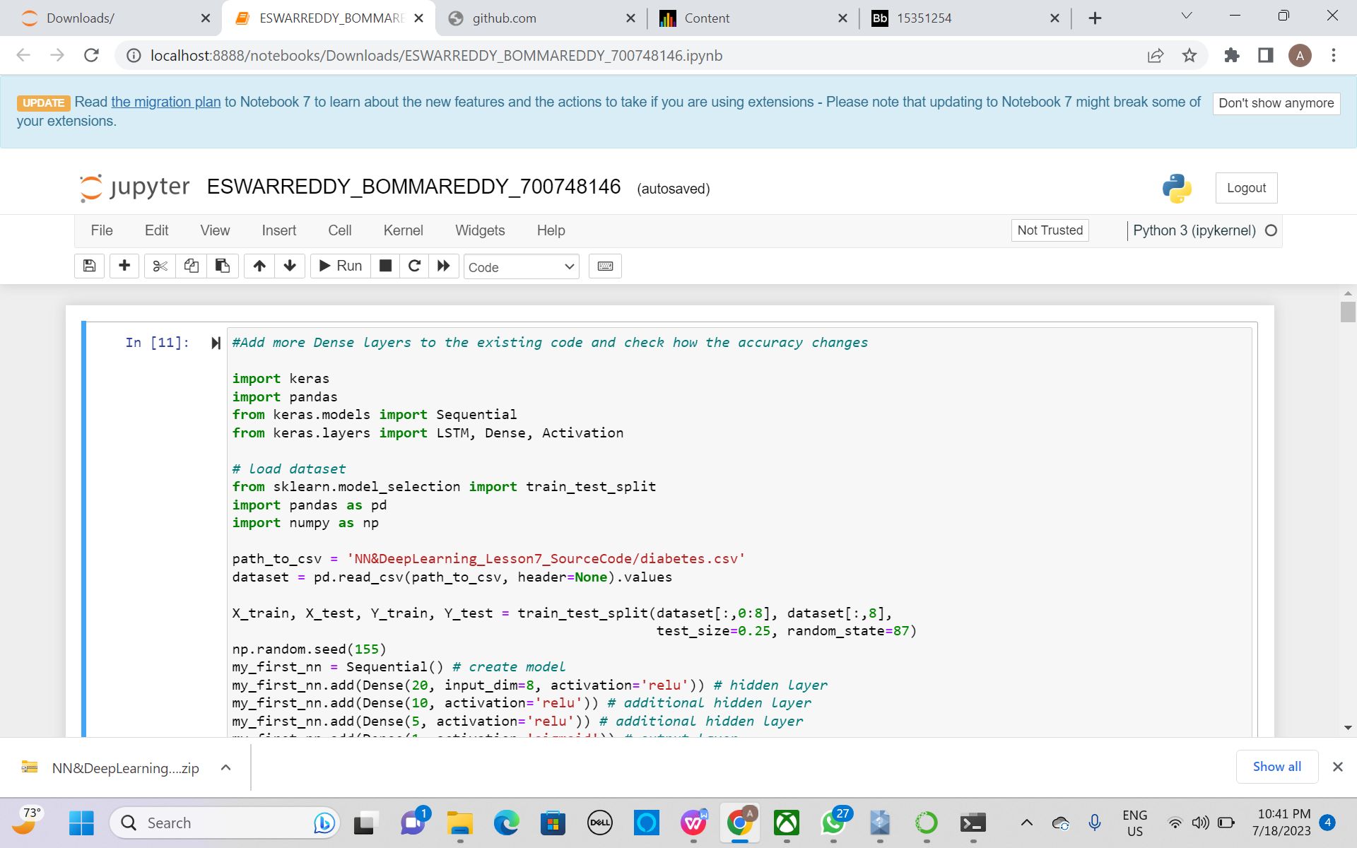

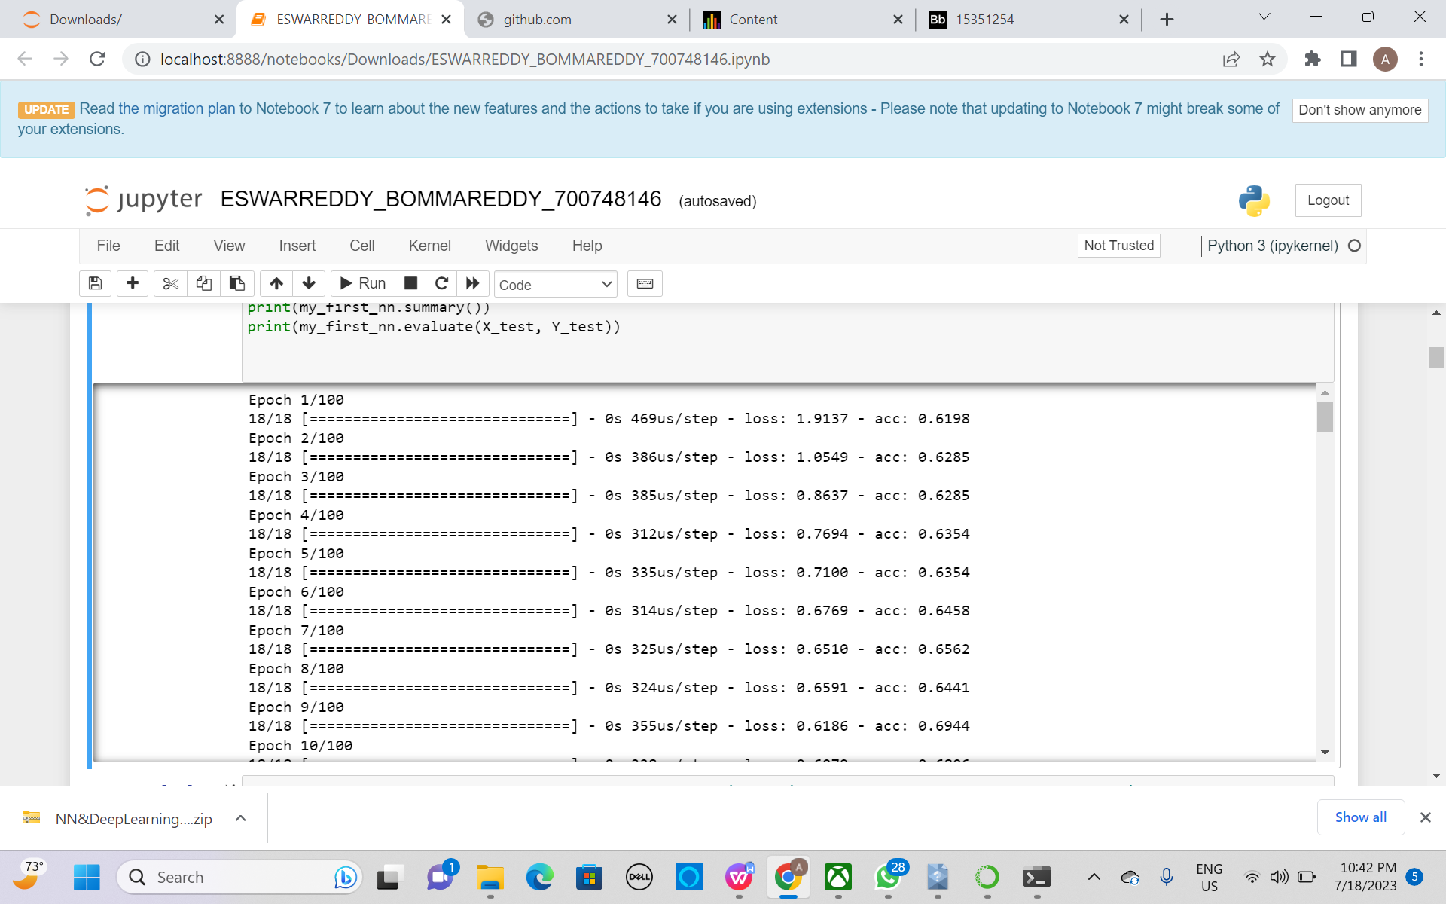

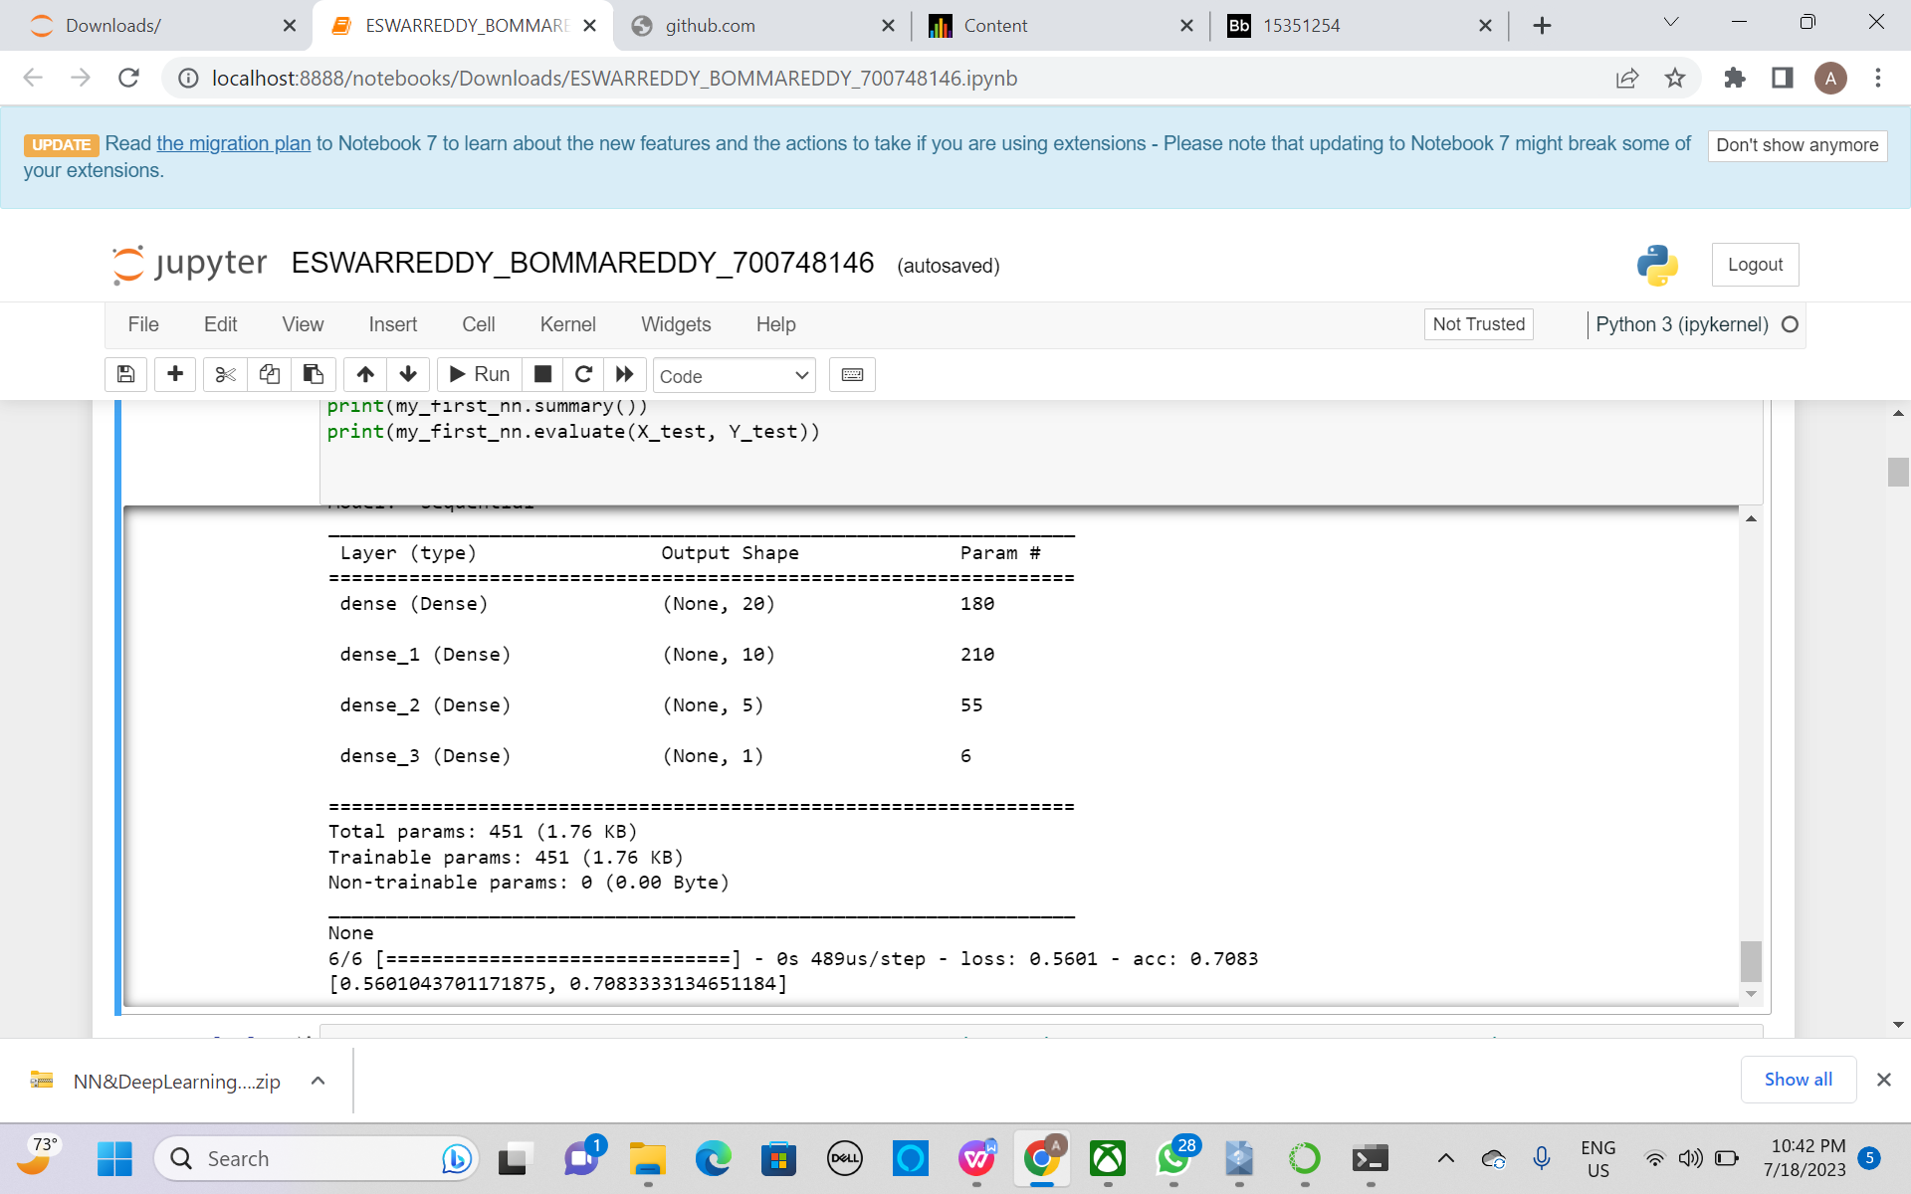

1. **Change the data source to Breast Cancer dataset * available in the source code folder and make required changes. Report accuracy of the model.**

Here just changed the dataset to Bread cancer dataset and made required changes. And found the accuracy model.

Used sequential model to train the data.

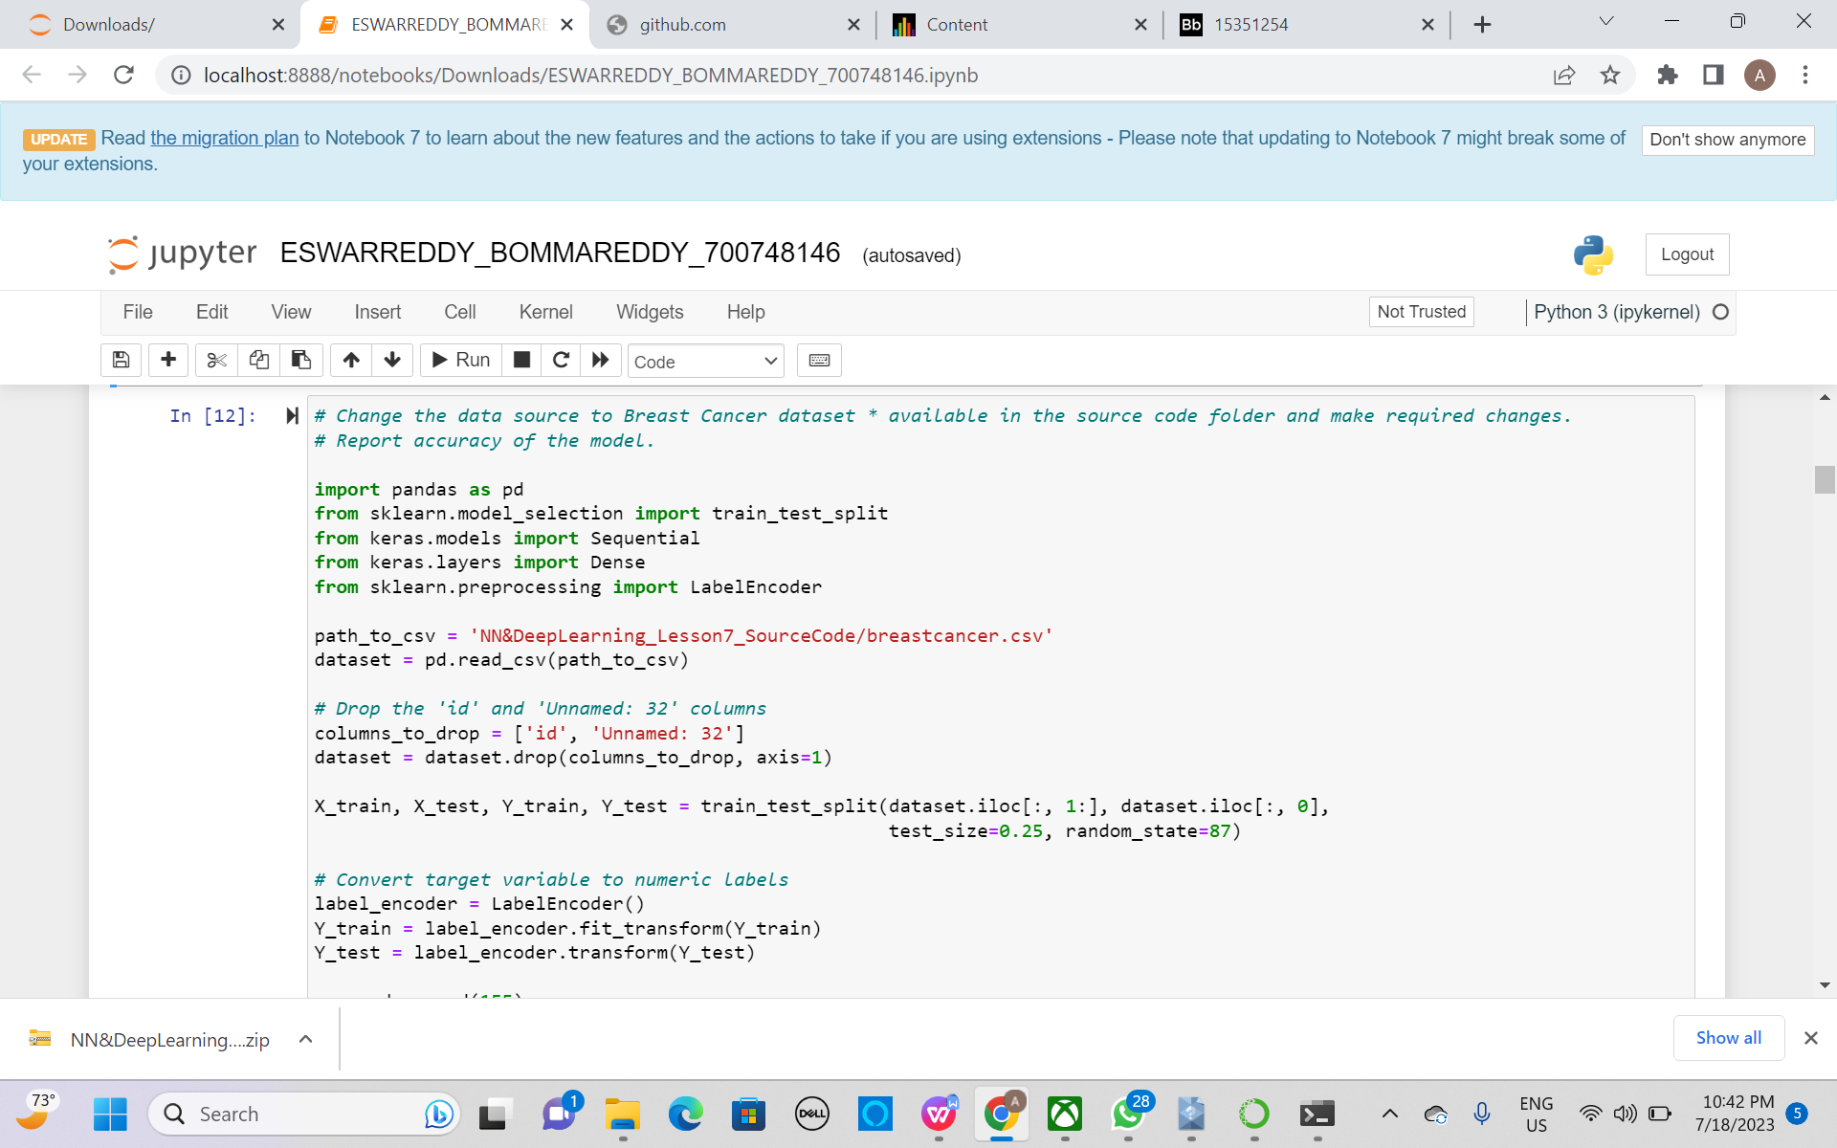

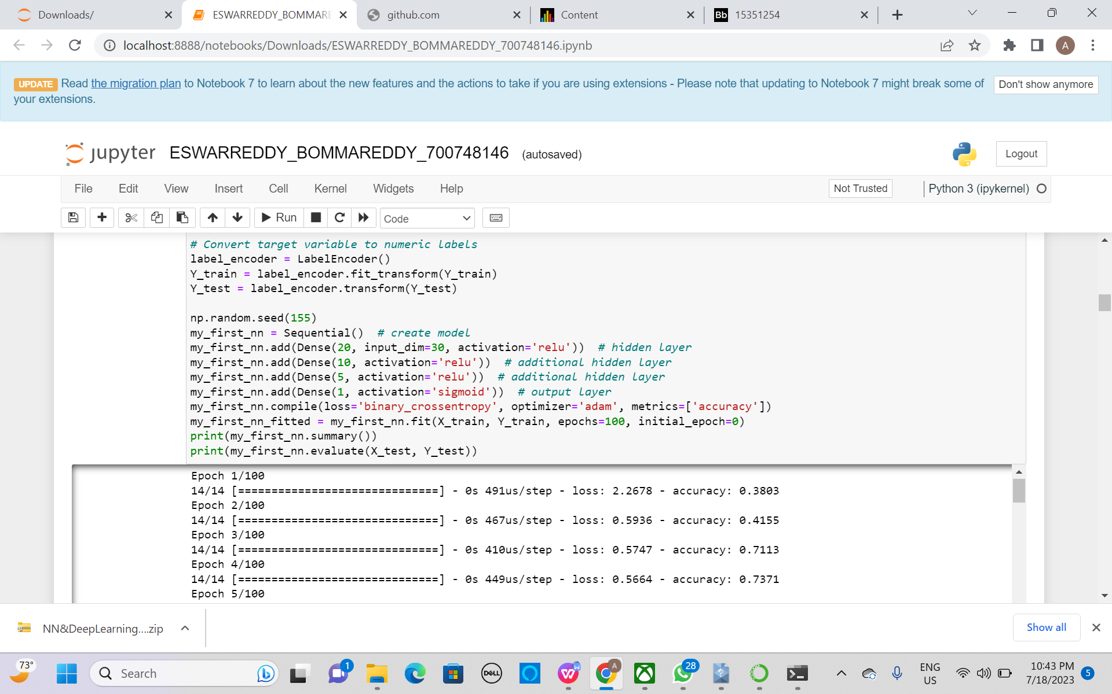

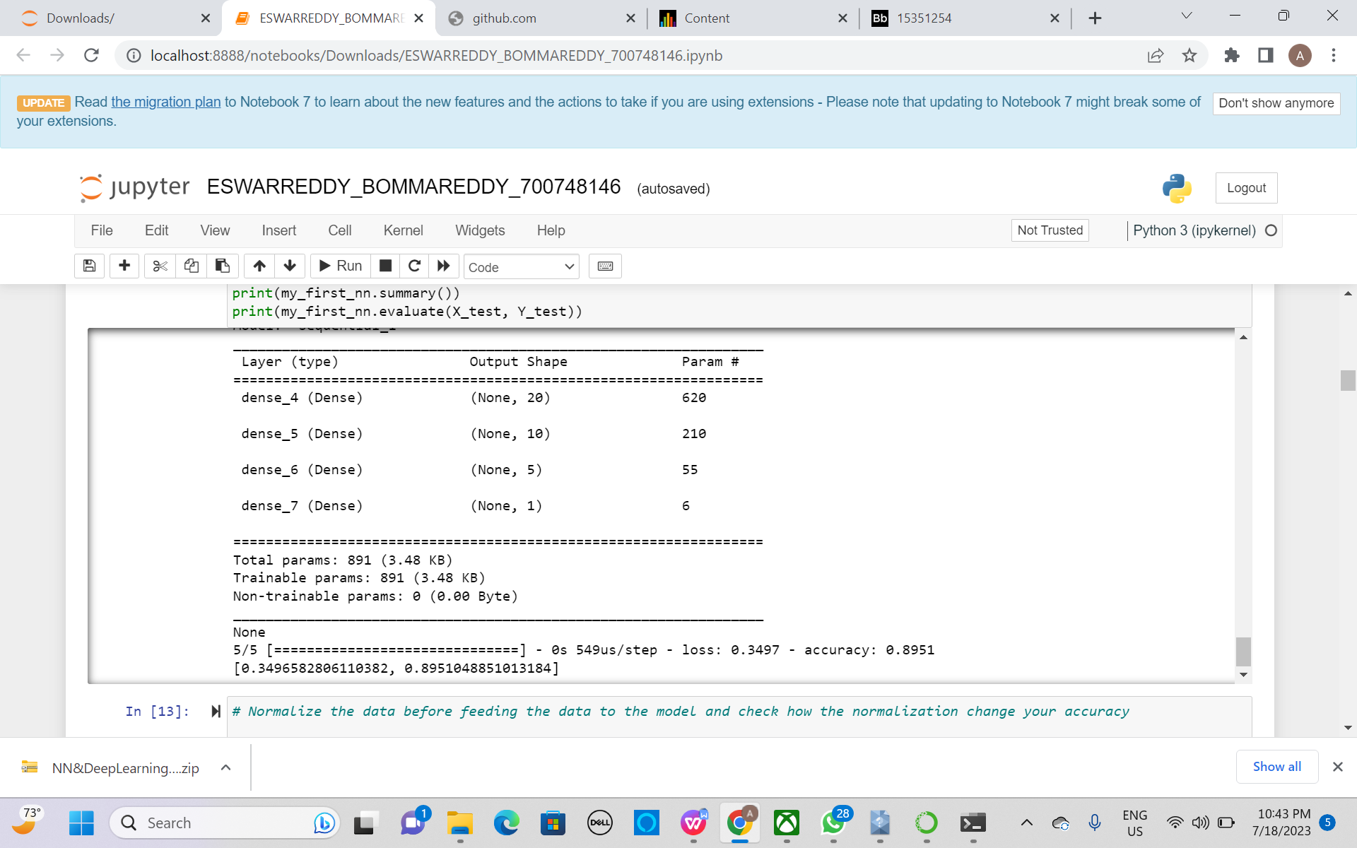

1. **Normalize the data before feeding the data to the model and check how the normalization change your accuracy (code given below). from sklearn.preprocessing import StandardScaler sc = StandardScaler()**

Using the standard scaler, checked the normalization change .

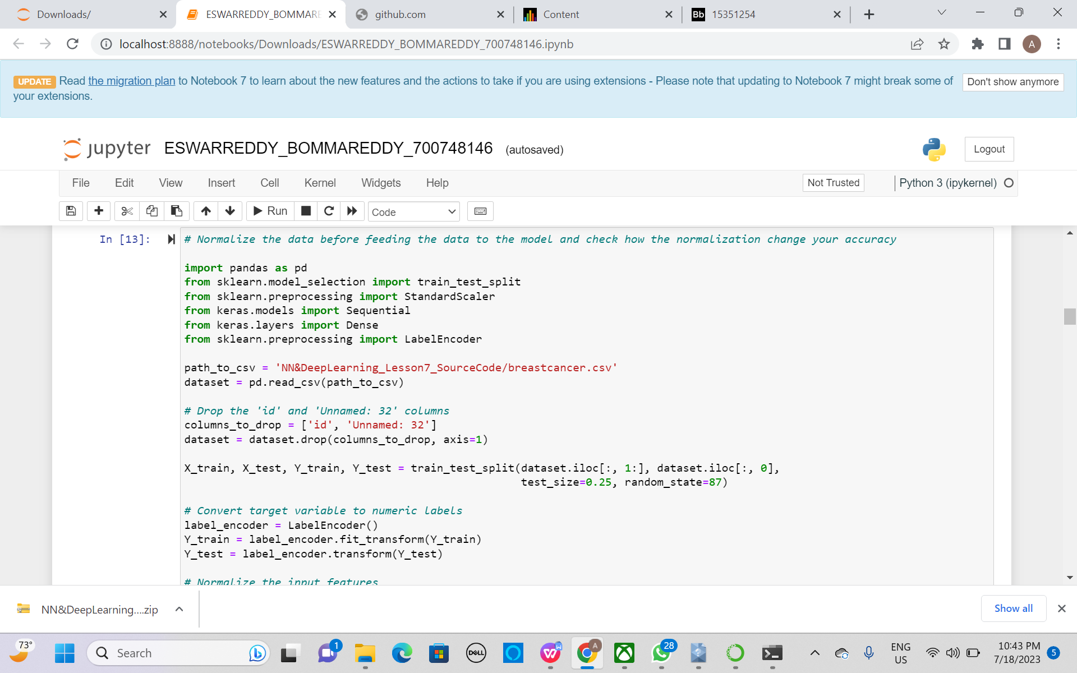

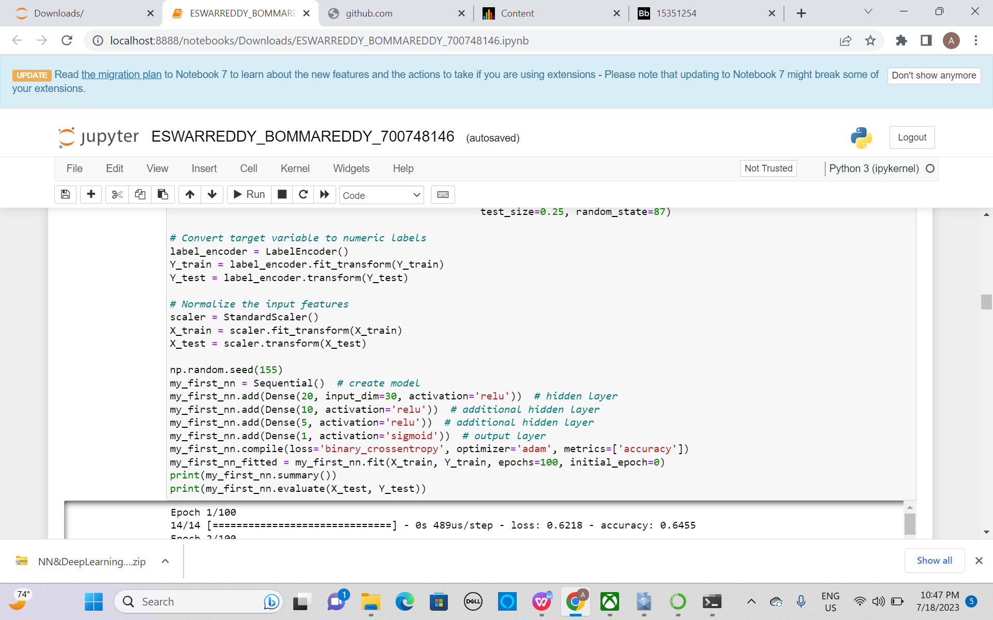

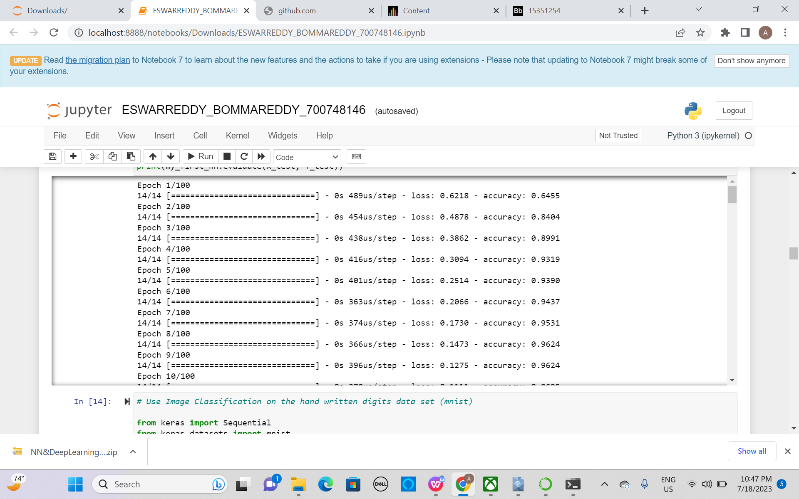

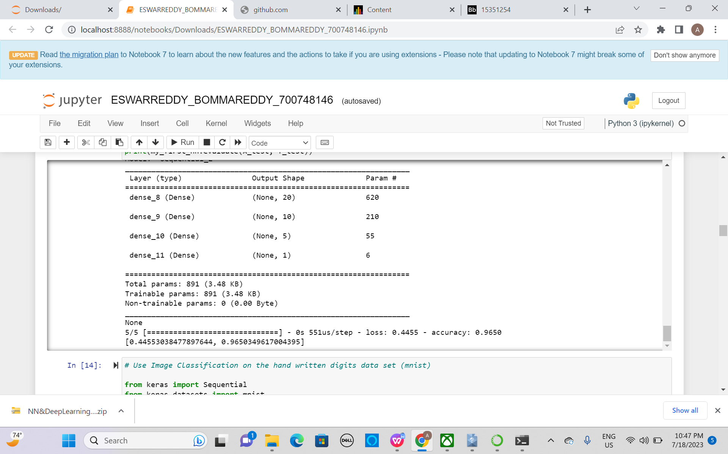

**Use Image Classification on the hand written digits data set (mnist)**

1. **Plot the loss and accuracy for both training data and validation data using the history object in the source code.**

Used image classification on the hand written data.

Imported necessary libraries and plotted data for both training data and validation data using the source code.

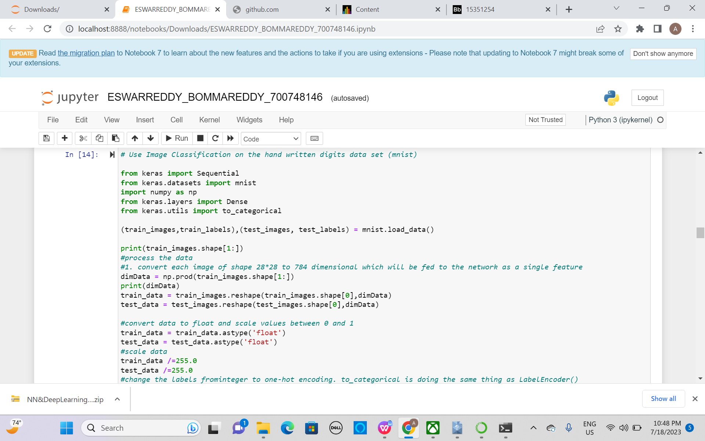

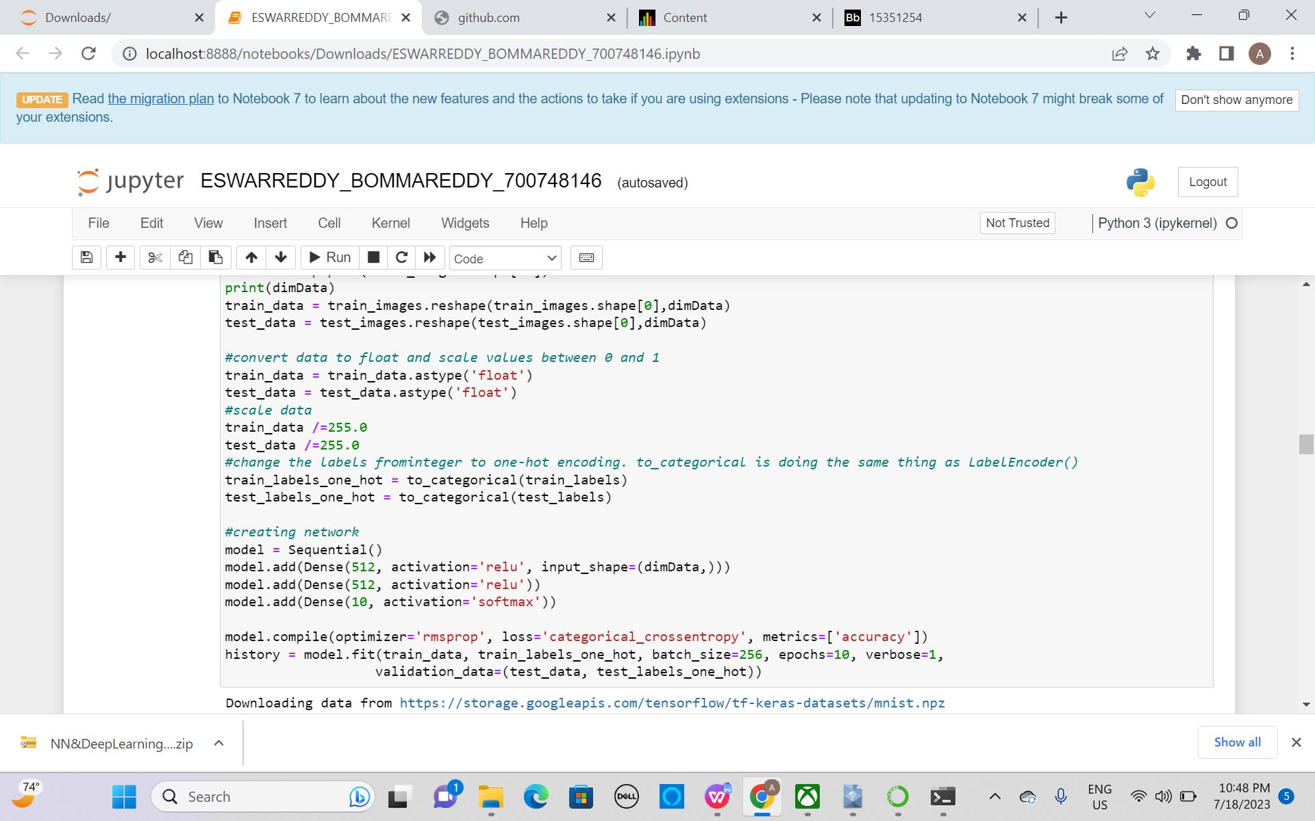

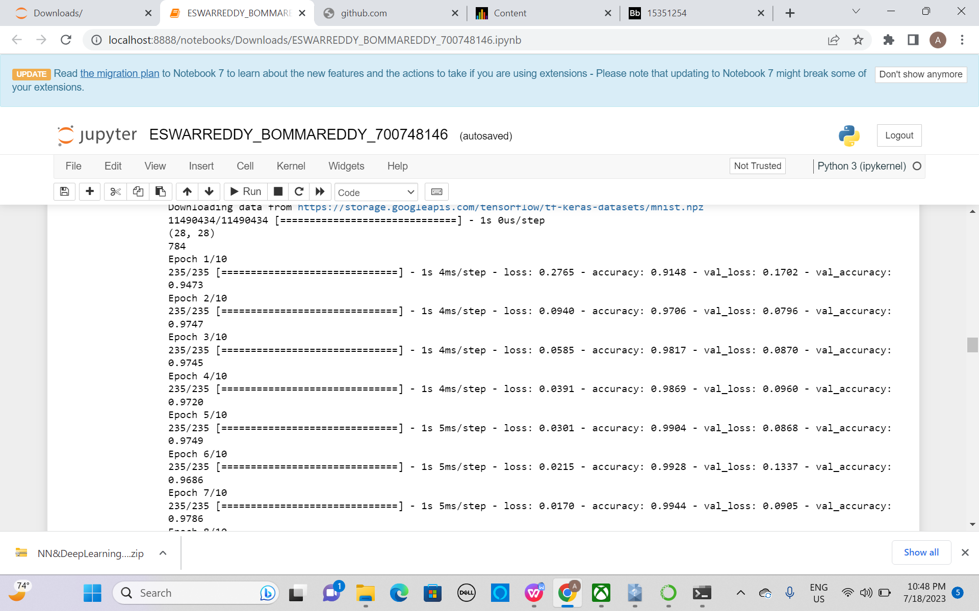

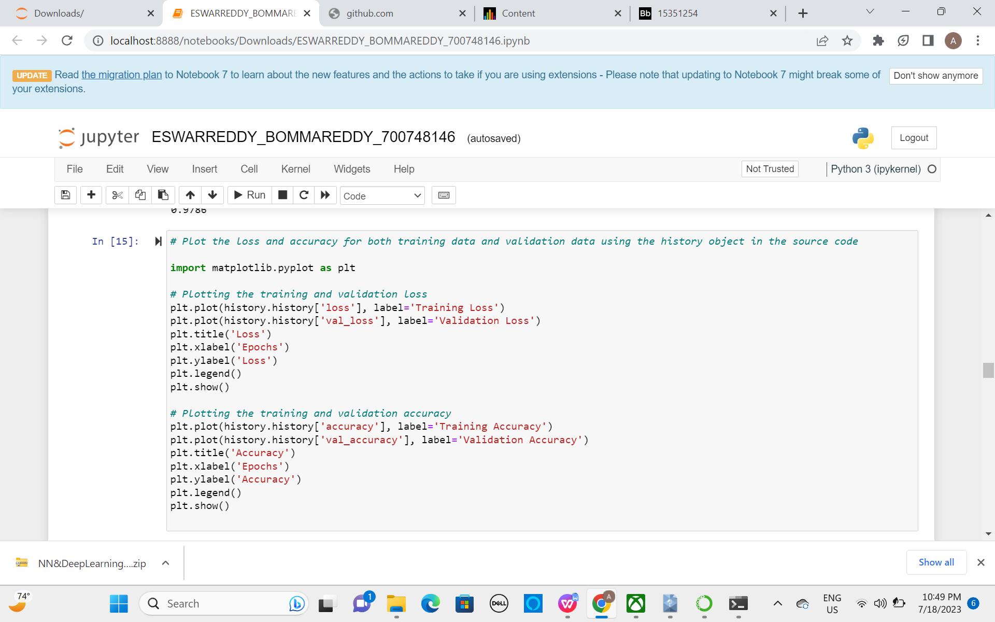

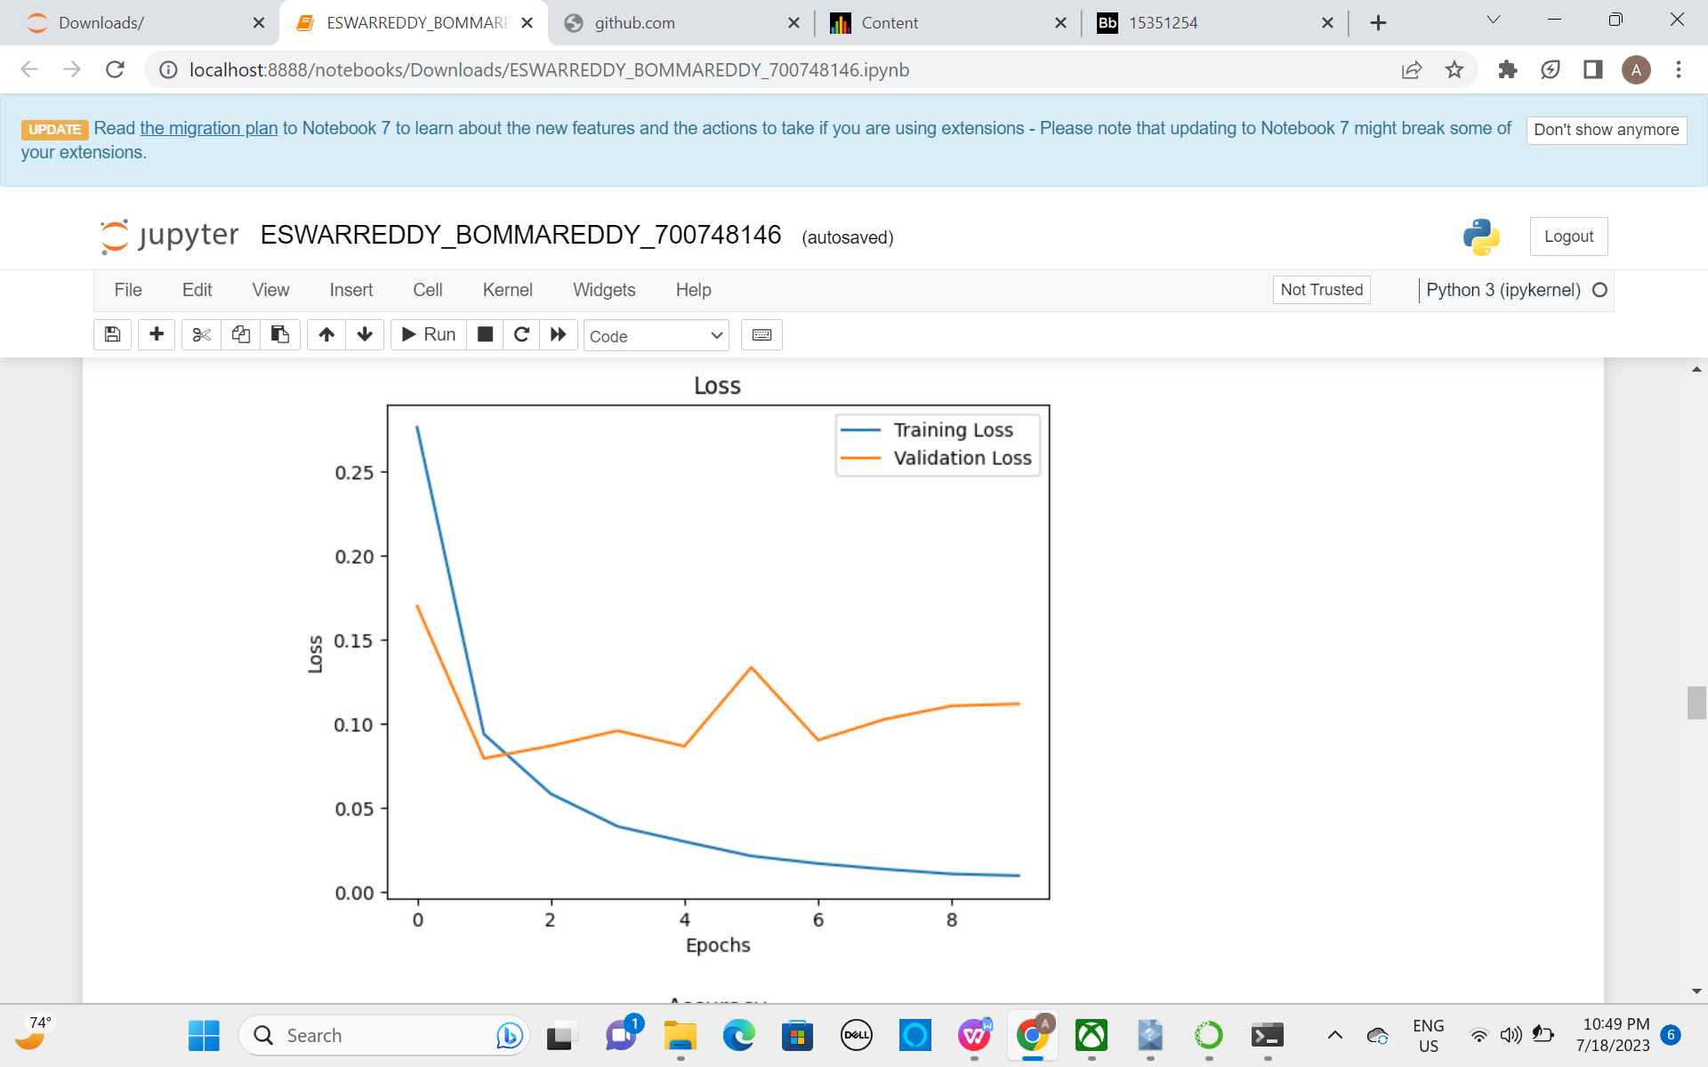

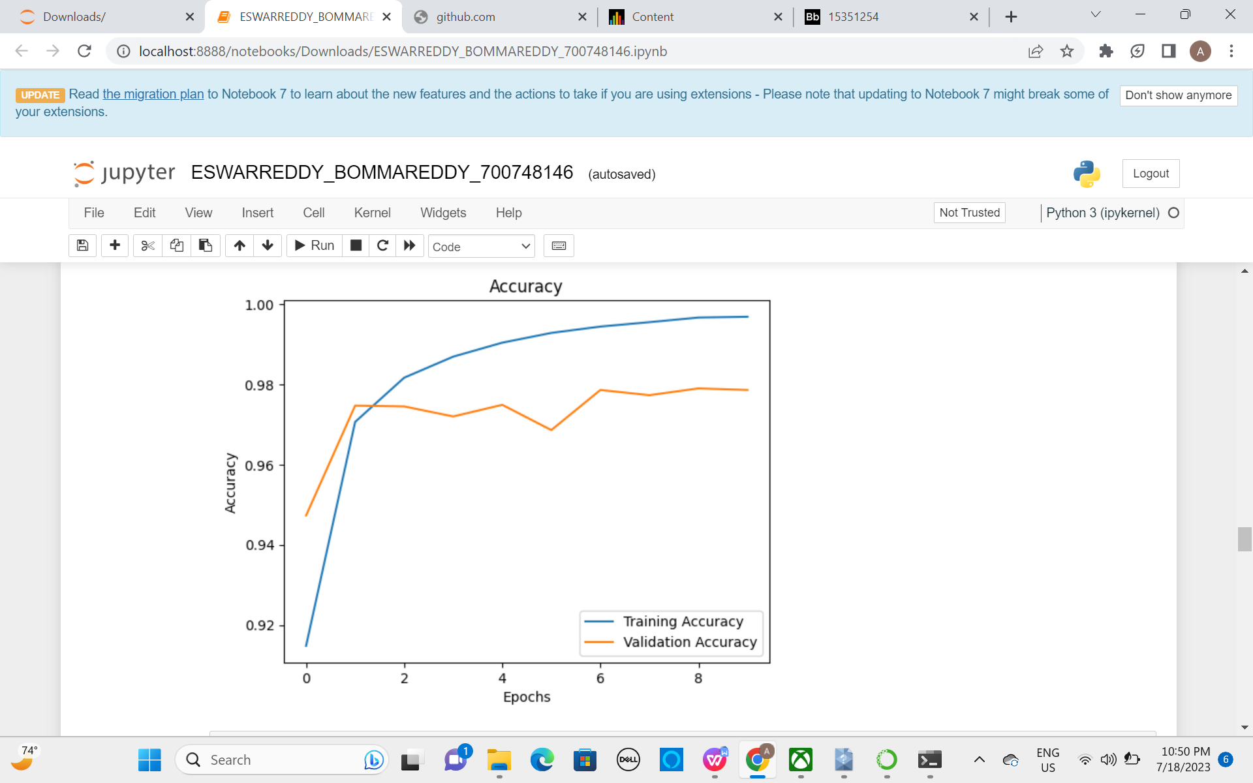

**B Plot one of the images in the test data, and then do inferencing to check what is the prediction of the model on that single image.**

Plotted one of the image in test data and predicted model on that image.

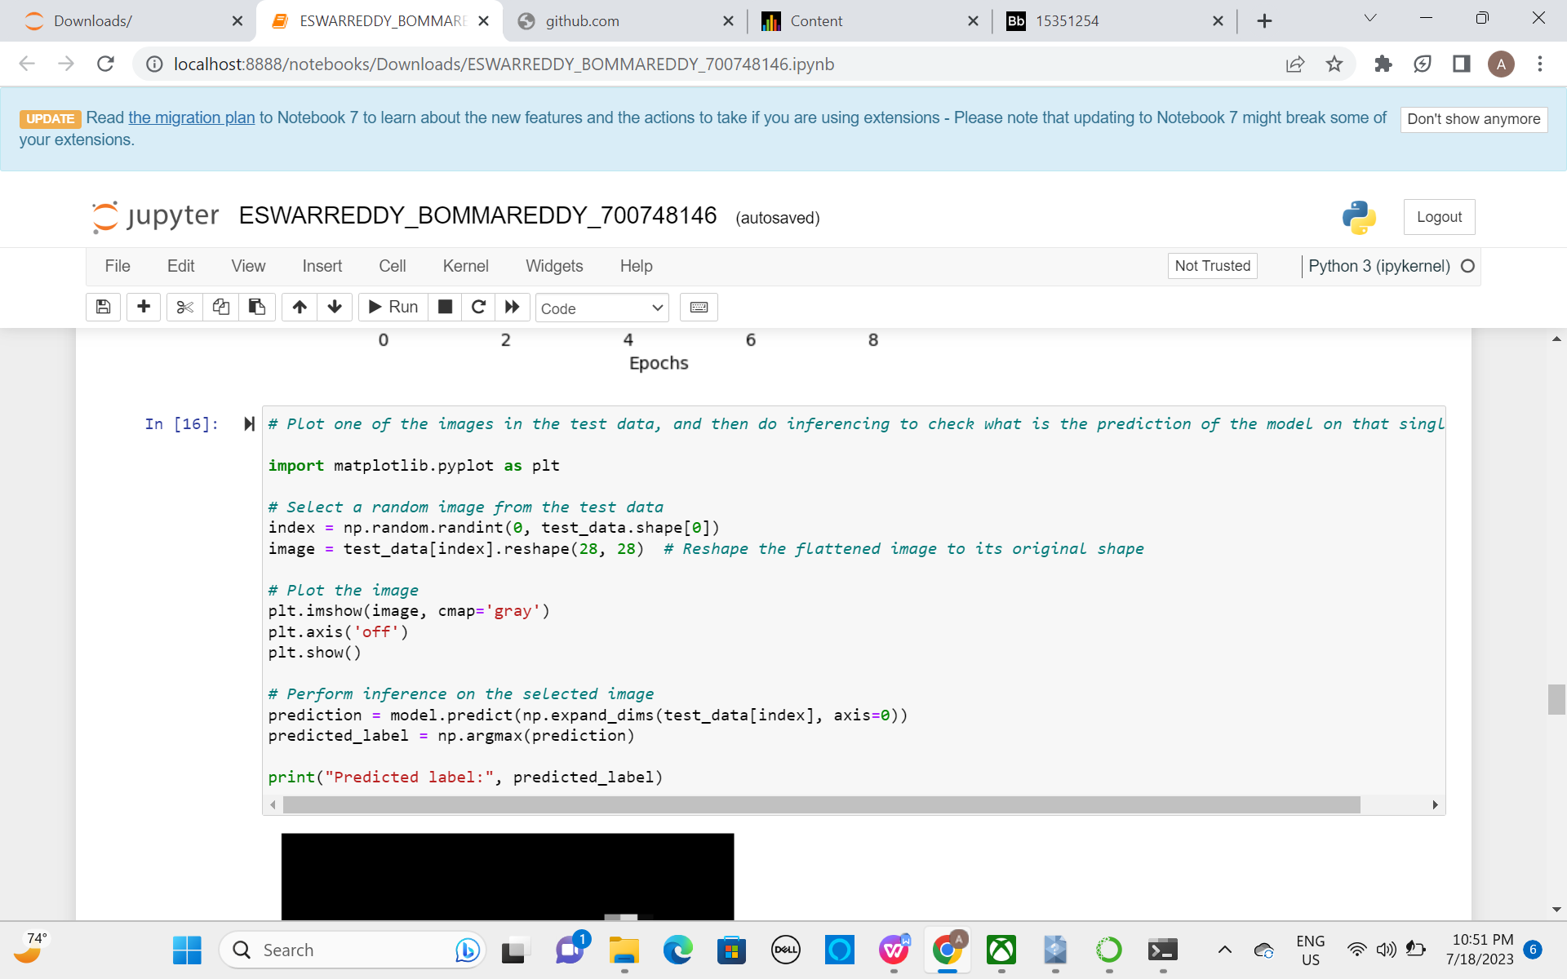

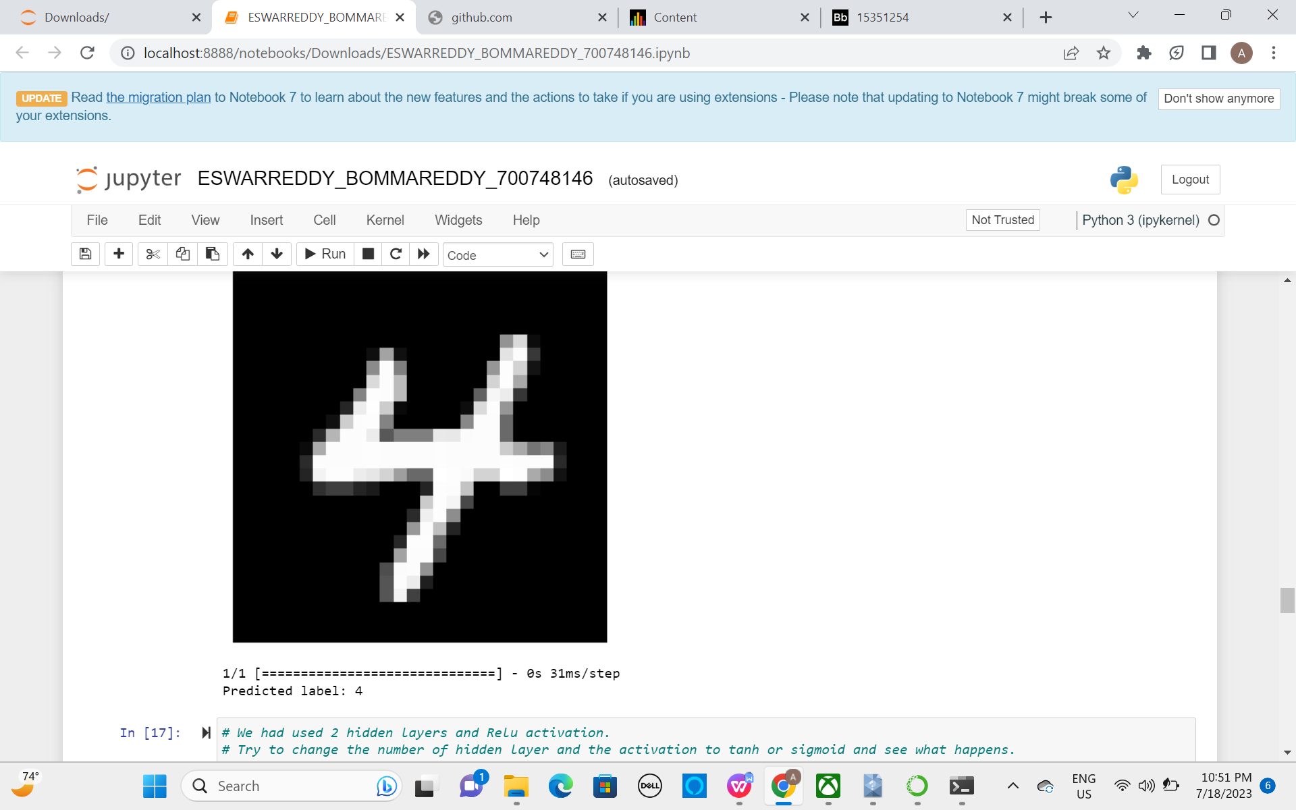

**3 We had used 2 hidden layers and Relu activation. Try to change the number of hidden layer and the activation to tanh or sigmoid and see what happens**.

Changed the number of hidden layer and activation to tanh

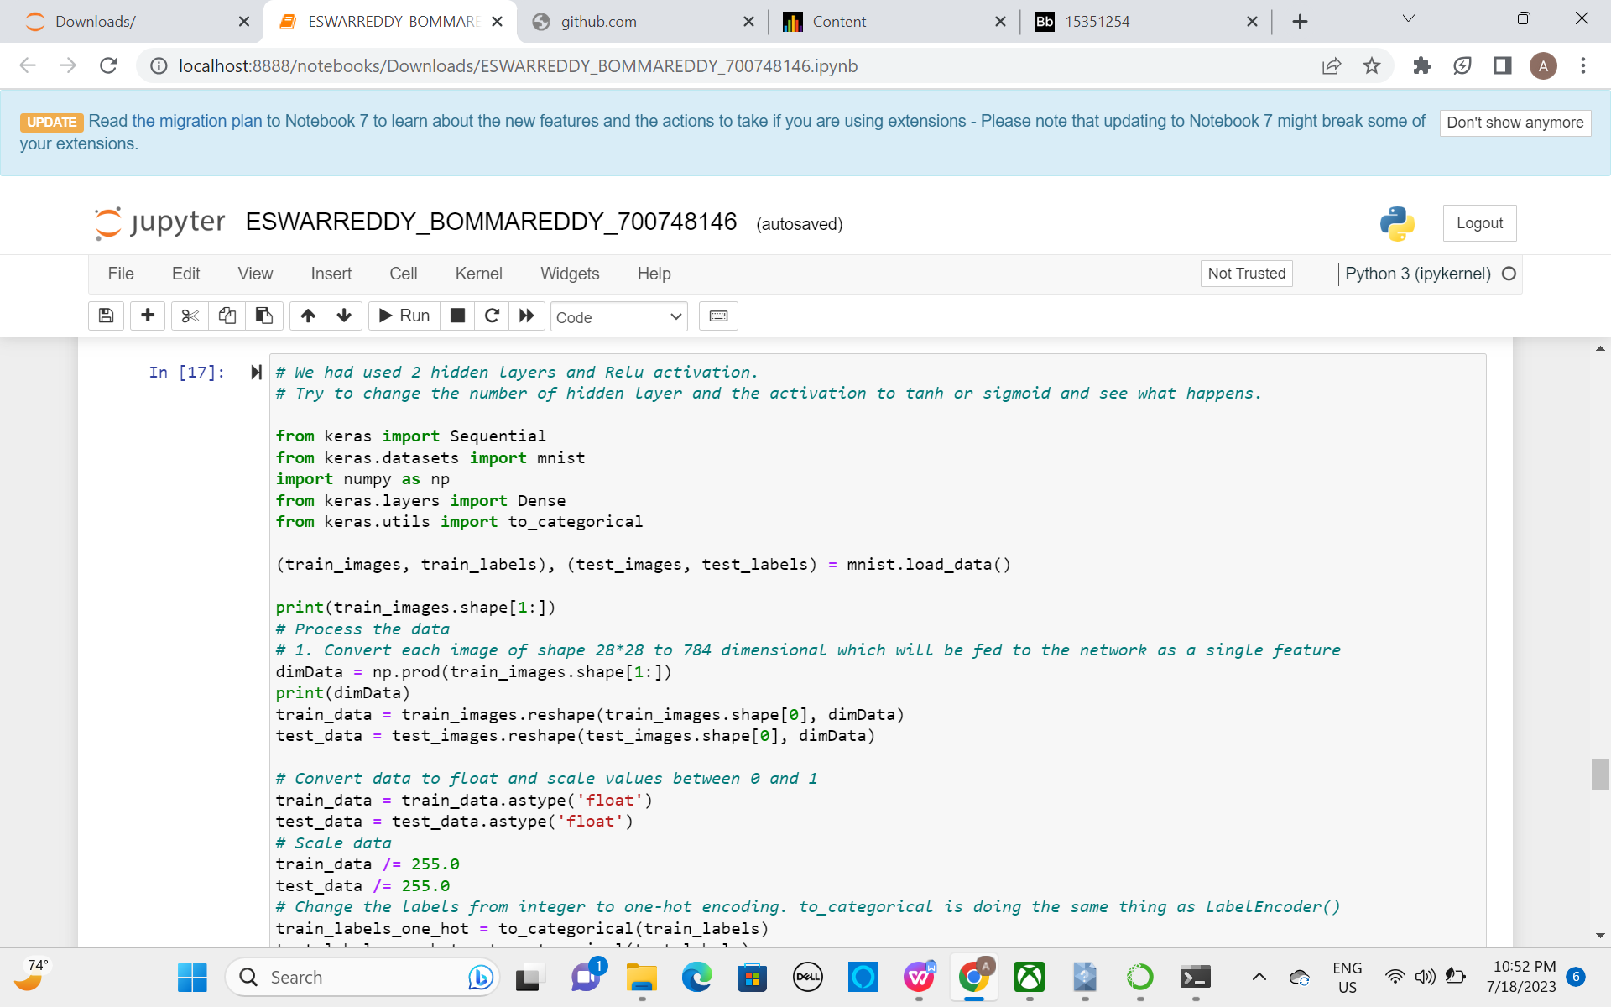

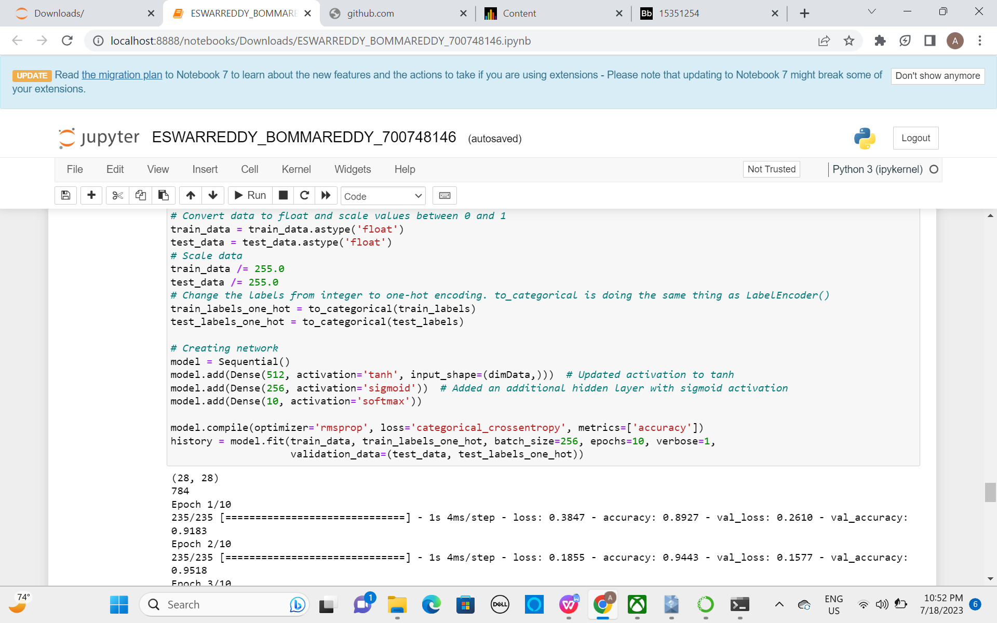

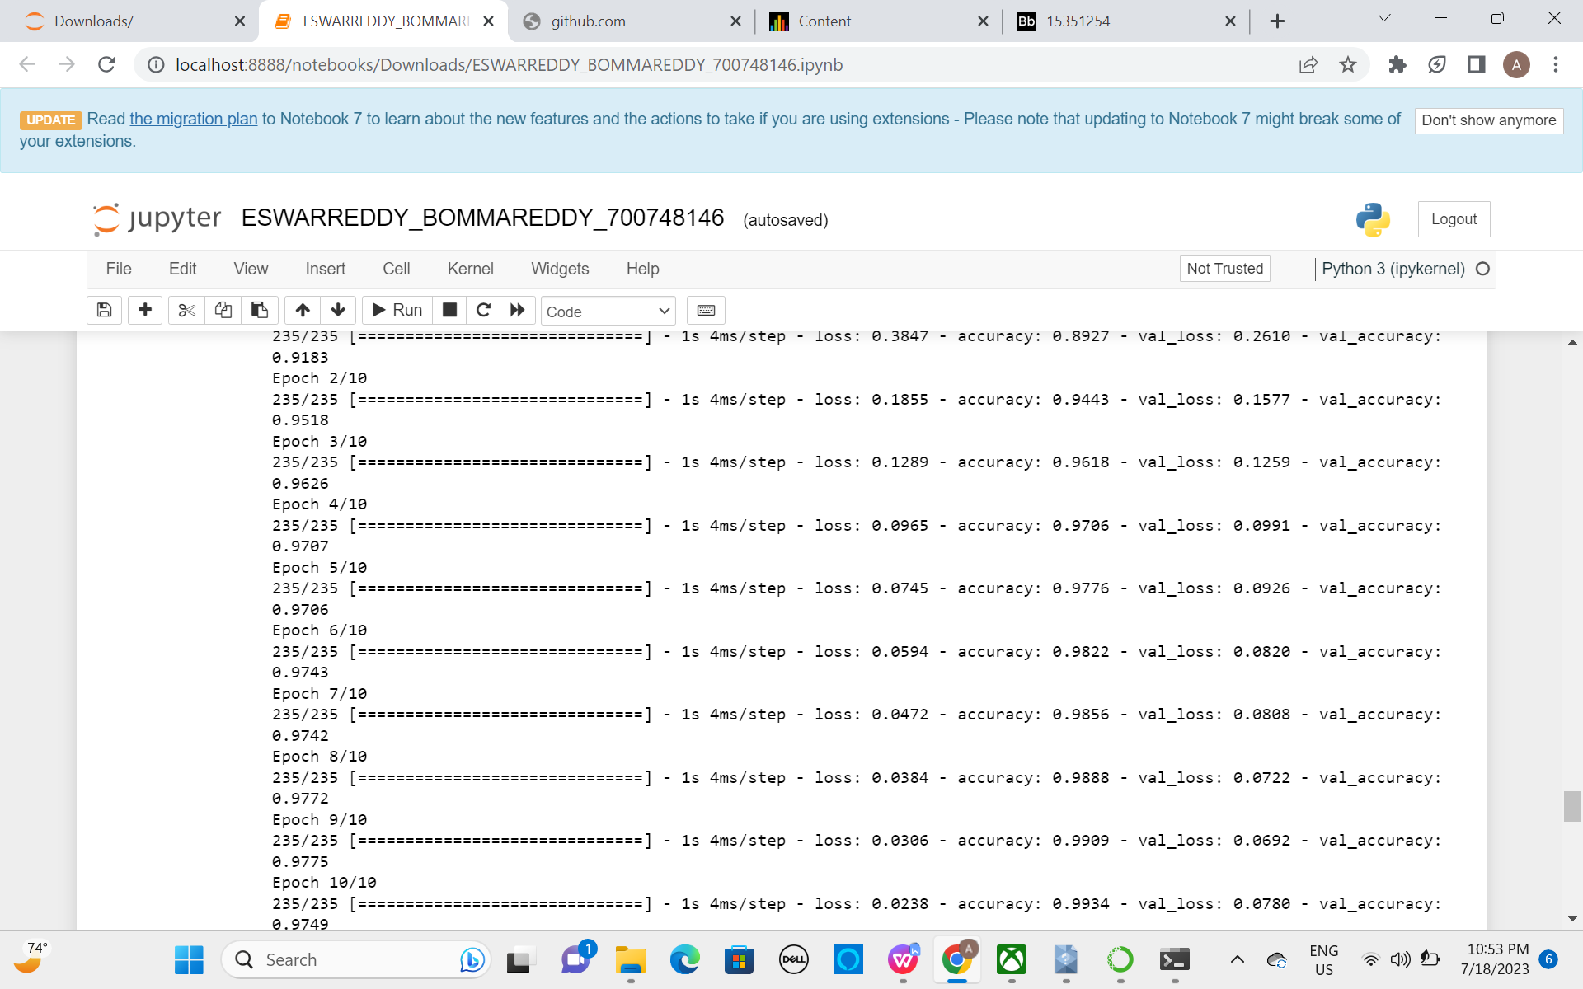

1. **Run the same code without scaling the images and check the performance?**

Executed the same code without scaling images and checked performance. Here are the results of it.

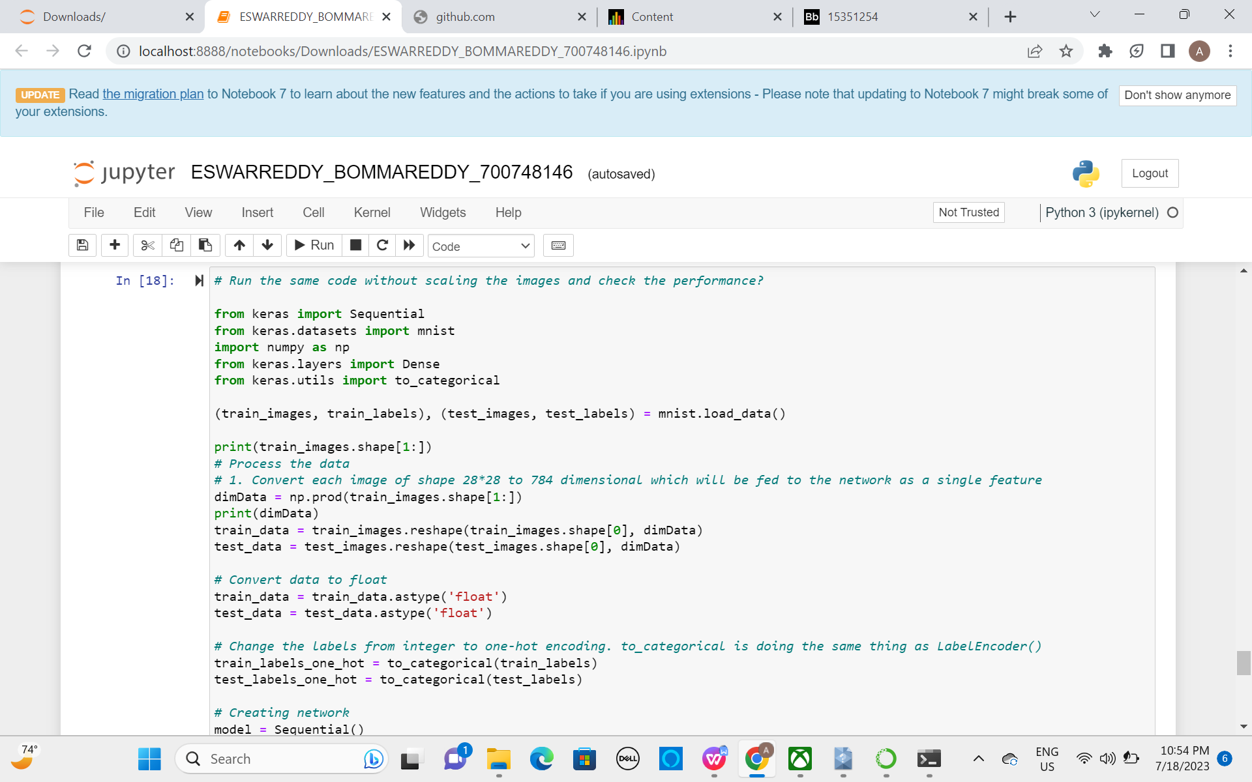

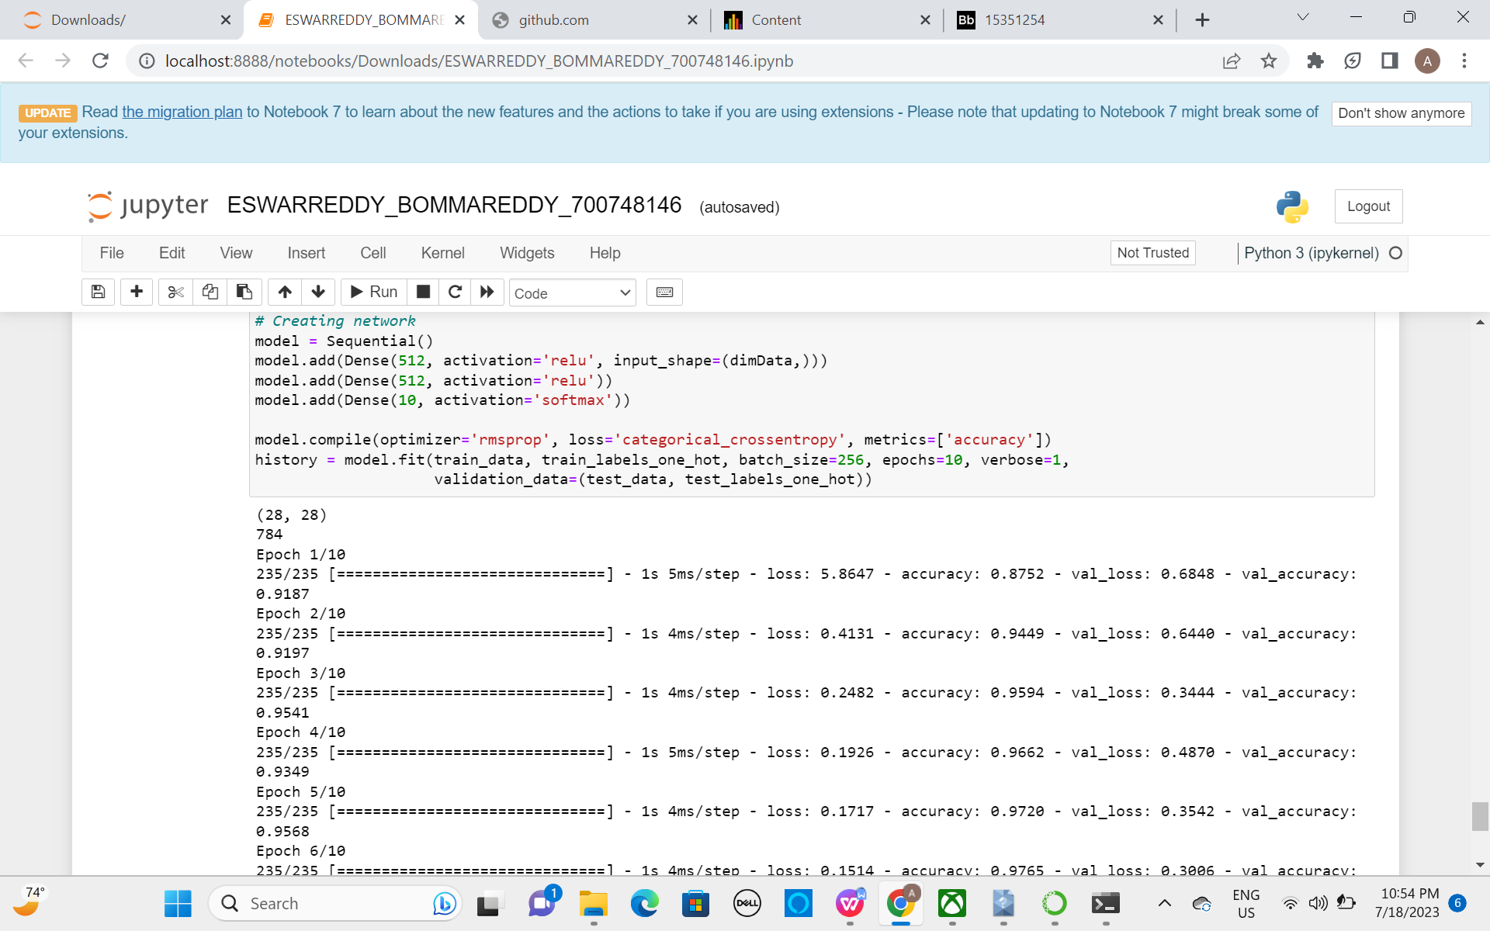

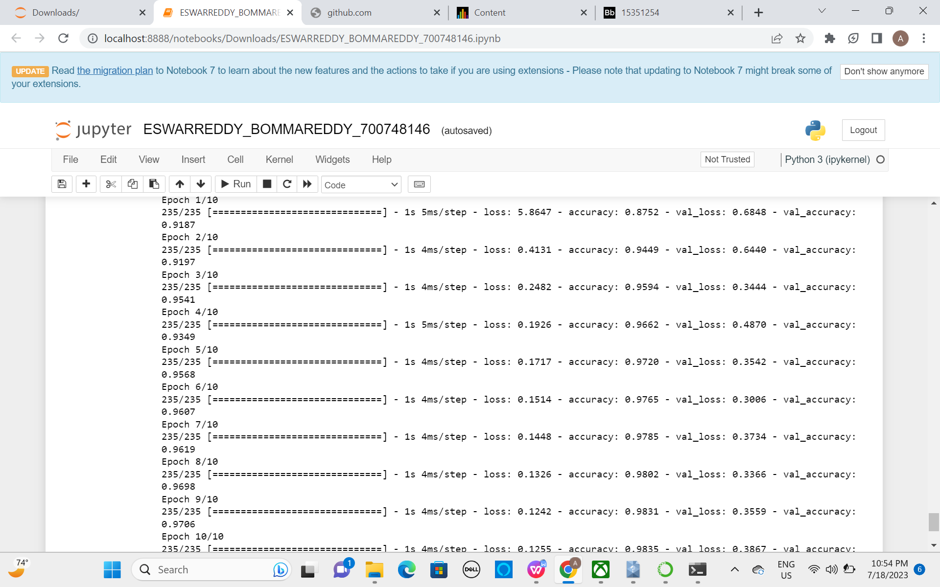

**Github link**

<https://github.com/EswarreddyaAaaaa/ESWAR_NEURALNETWORKS_ASSIGN2>

**Videolink**

**<https://github.com/EswarreddyaAaaaa/ESWAR_NEURALNETWORKS_ASSIGN2/blob/main/ESWAR.mp4>**